CS/Math 335: Activity 11, September 21

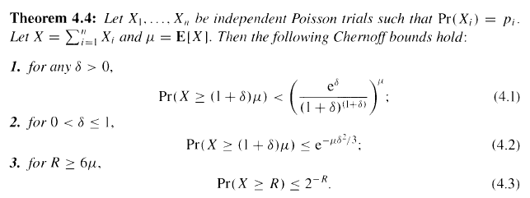

Example 1: Let X₁, X₂, …, X₈ be flips of a fair coin, with values 1 for heads and 0 for tails. All the p_{i} above are .5, and X can take values 0, 1, 2, …, 8. The mean of X is 4. Use (4.1) to bound P(X$≥$6). Here 1 + $δ$ = 1.5, because 6 = 1.5 * 4 and $μ$ = 4. So $δ$ = .5 and we see that
P(X$≥$6) < ${\left(\frac{e^{.5}}{{1.5}^{1.5}}\right)}^{4}≈.649$. As X is binomial, in this case we can compute the true probability of X$≥$6 as .109 + .031 + .004 = .144. Indeed, .144 < .649, but the .649 was much easier to compute.

Example 2: For the same X as above, determine what (if anything) (4.2) and (4.3) say about P(X$≥$6).

Example 3: What does 4.1 say about P(X = 8) in the example above?

Example 4: Approximate the probability of obtaining 55 or more heads when flipping a fair coin 100 times by an explicit calculation, and compare this with the Chernoff bound. Do the same for 550 or more heads in 1000 flips.

Example 5: If you roll a standard six-sided dice 600 times, bound the probability that you see 6 as the top face more than 200 times.

Example 6: We have a standard six-sided die. Let X be the number of times that a 6 occurs over n throws of the die. Let p be the probability of the event X $≥n/4$. Compare the best upper bounds on p that you can obtain using Markov's inequality, Chebyshev's inequality, and Chernoff bounds.

Example 7: Alice and Bob play checkers often. Alice is a better player. so the probability that she wins any given game is 0.6, independent of all other games. They decide to play a tournament of n games. Bound the probability that Alice loses the tournament using a Chernoff bound.

CS/Math 335: Activity 11, September 21, page 2

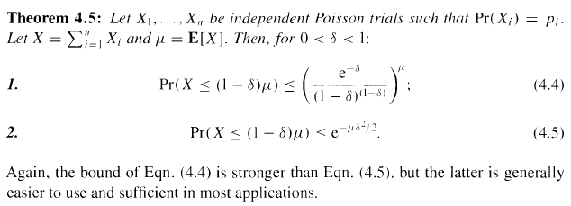
Example 8: Let X₁, X₂, …, X₈ be flips of a fair coin, with values 1 for heads and 0 for tails. All the p_{i} above are .5, and X can take values 0, 1, 2, …, 8. The mean of X is 4. Use (4.4) to bound P(X$≤$2). Here 1 - $δ$ = .5, because 2 = .5 * 4 and $μ$ = 4. So $δ$ = .5 and we see that
P(X$≤$2) < ${\left(\frac{e^{-.5}}{{.5}^{.5}}\right)}^{4}≈.541$. As X is binomial, in this case we can compute the true probability of X$≤$2 as .109 + .031 + .004 = .144. Indeed, .144 < .541, but the .541 was much easier to compute.

Example 9: For the same X as above, determine what (4.5) says about P(X$≤$2).

Example 10: What does 4.4 say about P(X = 0) in the example above?

Example 11: Approximate the probability of obtaining 45 or fewer heads when flipping a fair coin 100 times by an explicit calculation, and compare this with the Chernoff bound. Do the same for 450 or fewer heads in 1000 flips.

Example 12: If you roll a standard six-sided dice 600 times, bound the probability that you see 6 as the top face fewer than 20 times.

Example 13: We have a standard six-sided die. Let X be the number of times that a 6 occurs over n throws of the die. Let p be the probability of the event X $≤n/12$. Compare the best upper bounds on p that you can obtain using Markov's inequality, Chebyshev's inequality, and Chernoff bounds.

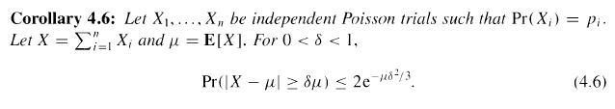
Example 15: Let X₁, X₂, …, X₈ be flips of a fair coin, with values 1 for heads and 0 for tails. All the p_{i} above are .5, and X can take values 0, 1, 2, …, 8. The mean of X is 4. Use (4.6) to bound
P(X$≤$2 or X$≥$6) = P(|X-4|$≥$2). Here $δ$ = .5, because 2 = .5 * 4 and $μ$ = 4. So we see that
P(|X-4|$≥$2) < $2e^{-4*\frac{{.5}^{2}}{3}}=2e^{-\frac{1}{3}}≈1.433$. Obviously, in this case, the upper bound is not very useful, since we already know that any probability is less than 1.

Example 16: For the same X as above, determine what (4.6) says about P(|X-4|$≥$4). Also, what values of X make up the event “|X-4|$≥$4”?

Example 17: Bound the probability of obtaining 5 or fewer or 95 or more heads when flipping a fair coin 100 times, using 4.6. Do the same for 50 or fewer or 950 or more heads in 1000 flips.

Example 18: Suppose you roll a standard six-sided dice 600 times, and X is the number of times the top face is a 6. What value of $δ$ guarantees that the probability p, of X being at least $δμ$ away from its expected value, is at most .01? What values of X are you bounding the probabilities of?

Example 19: We have a standard six-sided die. Let X be the number of times that a 6 occurs over n throws of the die. Let p be the probability of the event X $≤n/12$ or X $≥n/4$. Compare the best upper bounds on p that you can obtain using Markov's inequality, Chebyshev's inequality, and Chernoff bounds.

Example 20: We plan to conduct an opinion poll to find out the percentage of people in a community who want its president impeached. Assume that every person answers either yes or no. If the actual fraction of people who want the president impeached is p, we want to find an estimate X of p such that Pr(|X-p|$≤εp$) > 1-$δ$ for a given $ε$ and $δ$ between 0 and 1. We query N people chosen independently and uniformly at random from the community, and we output the fraction of them who want the president impeached. How large should N be for our result to be a suitable estimator of p? Use Chernoff bounds, and express N in terms of p, $ε$, and $δ$. Calculate the value of N from your bound if $ε$ = 0.1 and $δ$ = 0.05 and if you know that p is between 0.2 and 0.8.

Meta-Algorithm to use Chernoff bounds…
- Find the expected value $μ$ of X
- Write the event you care about in the form P(X $≤$ z) or P(X $≥$ z)
- Select which Chernoff bound (4.1, 4.2, etc) you want to use
- Solve for $δ$, using $μ$, z, and the formula from the Chernoff bound
- Plug your values for $δ$ and $μ$ into the Chernoff bound from (3) and simplify the formula to get an upper bound on the probability. Your bound should be a number or a formula involving n. It should not have a $δ$ or $μ$.

