Homework 2
CS-377 Spring 2004
Due: February 3, 2004

- (12 pts) Consider two separate banks that decide to merge. Assume that both banks use exactly the same E-R database schema – the one in Figure 2.22 of the textbook. If the merged bank is to have a single database, there are several potential problems:
- The possibility that the two original banks have branches with the same name
- The possibility that some customers are customers of both original banks
- The possibility that some loan or account numbers were used at both original banks

For each of these potential problems, describe why there is indeed a potential for difficulties. Propose a solution to the problem. For your solution, explain any changes that would have to be made and describe what their effect would be on the schema and the data.

- (12 pts) Design a relational database corresponding to the following E-R diagram:

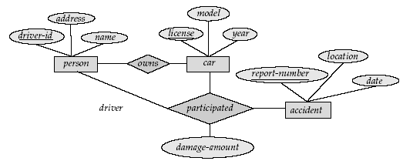

- (8 pts) In Chapter 2, we saw how to represent many-to-many, many-to-one, one-to-many, and one-to-one relationship sets. Explain how primary keys help us to represent such relationship sets in the relational model.

- (10 pts) Following is an E/R diagram for a bank database involving customers and accounts. Since customers may have several accounts, and accounts may be held jointly by several customers, we associate with each customer an “account set,” and accounts are members of one or more account sets. Assuming the meaning of the various relationships and attributes are as expected given their names, criticize the design. What design principles are violated? Why? What modifications would you suggest?

owner-address
AcctSets
Accounts
number
balance
address
name
Customers
Addresses
Member
LivesAt
Has

- (12 pts) Convert the following E/R diagram for an airline enterprise to a relational database schema:

Bookings
Customers
Flights
toCust
toFlt
row
seat
SSNo
name
addr
phone
number
aircraft
day

